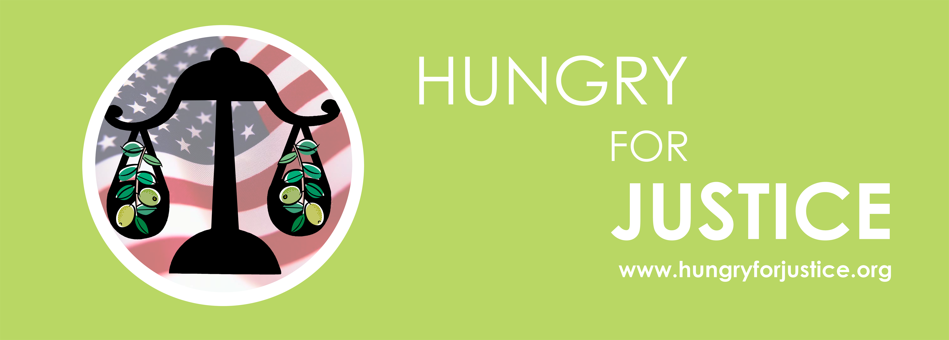 | HUNGRY FOR JUSTICE  www.hungryforjustice.org

For Immediate Release

Contact: Khalil Meek, Spokesperson

972-849-9188 khalilmeek@gmail.com

Lydia Gonzalez Welch

214-704-8383 lydia@ivuemedia.com

HOLY LAND FOUNDATION FAMILY MEMBERS
INSIST ON A FAIR RE-TRIAL

FIRST TRIAL RESULTED IN ZERO CONVICTIONS

September 22, 2008 – (Dallas, Texas) The family members of the Holy Land Foundation defendants don’t understand why there is a second trial when the first one resulted in zero convictions. They are asking the federal courts for due process and a fair re-trial. They will hold a press conference today just outside the federal courthouse along with other civil rights leaders and religious leaders; including Imam Mahdi Bray, Hon. Cynthia McKinney and Hon. Lon Bernam.

"Hopefully, the second time around will mark the end of this overblown persecution so my family can finally wake up from this nightmare,” said Noor Elashi. “My paternal grandmother, mom, five siblings and I need my dad to come out of the prosecution’s whirlpool of scrutiny and false accusations."

The Department of Justice has never before criminalized charitable acts and its theory of providing “humanitarian aid” and “feeding hungry children” is a flawed one. The senior most ranking U.S. Department of State official, in Palestine during the time period of the alleged “illegal humanitarian aid” testified that no U.S. intelligence agency considered any of the now alleged acts or organizations to be in support of or controlled by Hamas.

"My father and his friends don’t need to be on trial, save that for the criminals. Rather they should be honored for their charity work. Anything other than a ‘Not Guilty’ verdict will be a dishonor to America and everything it stands for. I’m positive the jury will vote in favor of America and its honor.” Said Sanabel Abu-Baker.
Even though other charities, including USAID, were performing the exact same humanitarian acts, during the exact same time period, with the exact same recipients; and yet those other organizations were not included in any criminal prosecution, un-indicted co-conspirators list, or any similar prosecutions. Those close to the defense contend that this is “an Israeli trial being tried on American soil.”
The Holy Land Foundation also provided the same humanitarian aid to other countries including the United States, Turkey, Pakistan and Bosnia. Zakat, similar to tithing for Catholics, is part of their core believes of providing charitable aid to those who need it the most.
The Hungry for Justice coalition appeals to the American public, because we all know that feeding hungry children is not a crime.
###

